FALL 2022 MEETING
Madison, WI
Oct 12–Oct 15

Thursday October 13, 2022

1:45 PM
J. JAMES TYE III
PAUL DEARLOVE
MATTHEW FRANK, ESQ.
A Clean Lakes Alliance Success story

3:00 PM
MARYAM GHAYYAD, ESQ.
Employment Based Immigration: Principles
And Practice

Thursday October 13, 2022 – Continued

4:00 PM
MATTHEW (MATT) FLEMING, ESQ.
ANTHONY (TONY) BARBIERI, ESQ.
NEAL WEINSTEIN, ESQ.
JANE (GINGER) ZIMMERMAN, ESQ.
Best Practices Panel – Post Covid Return to Work

Friday October 14, 2022

9:45 AM
TIM VALENTYN, ESQ.
“Show Me the Money” – Sports Agency in
Private Practice

11:00 AM
MARK MACIOLEK, ESQ.
Data Do’s and Data Do Not Do’s

Friday October 14, 2022 – Continued

1:30 PM
JAMES TINJUM, Ph.D.
Wind Energy: Opportunities and Challenges
For a Sustainable Energy Future

2:30 PM
MATTHEW (MATT) FLEMING, ESQ.
AMY GORES
CHANDLER SAUL, ESQ.
ANNE-ALISE (ALI) HINKLEY, ESQ.
Best Practices Panel – Law Firm Marketing 2.0

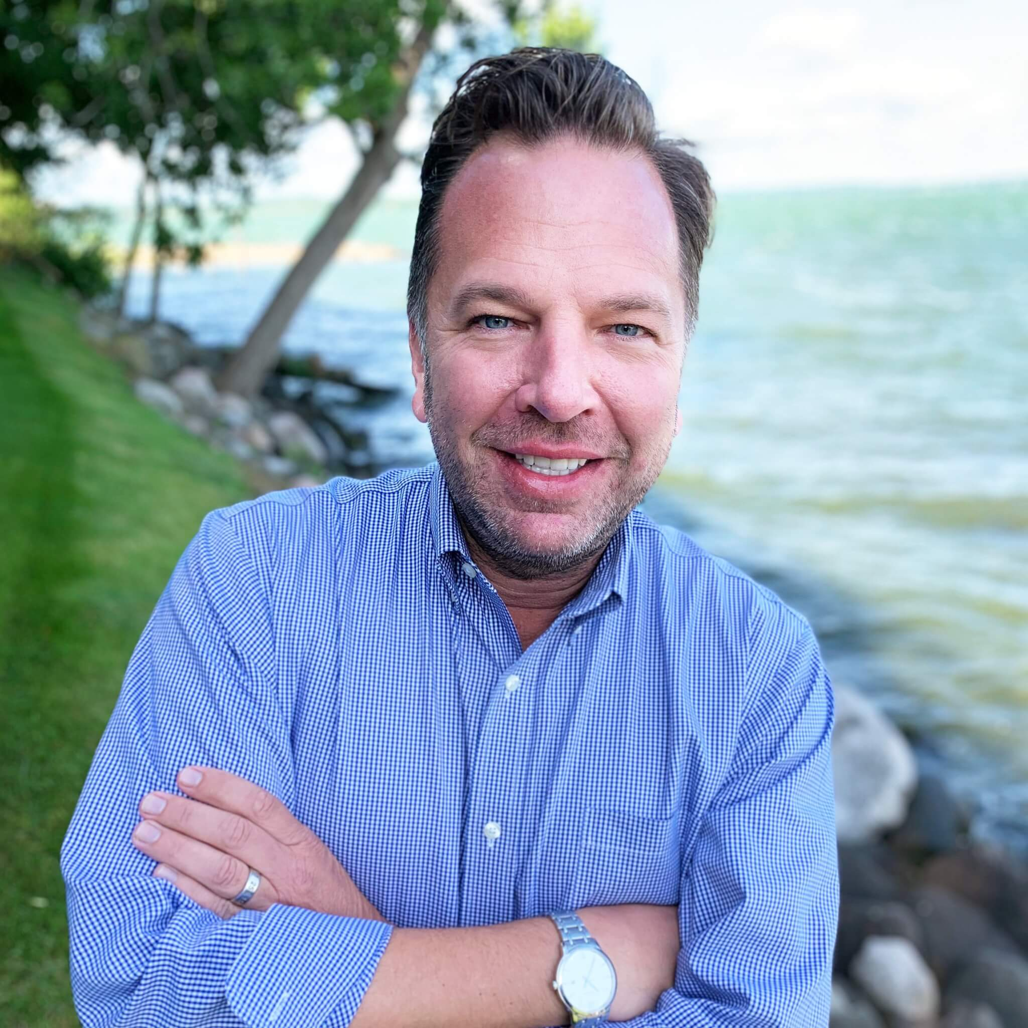
J. James Tye III

James is the Founder and Executive Director of Clean Lakes Alliance. His connection to the lakes runs deep, as he grew up swimming, waterskiing, and sailing on Lake Mendota. As a lifelong Madison resident, he has seen many changes in the Yahara lakes over the years and is excited to have the opportunity to work on their behalf.

Currently, his projects include the Yahara CLEAN Compact, marketing and promoting various lake events, creating more community engagement within the watershed, and continuing to expand the alliance of organizations, people, and businesses that care for our lakes.
James has experience working for both nonprofit and for-profit organizations, including Capital Newspapers and Downtown Madison, Inc. While working with Hype Communications on a project for Mad-City Ski Team, James identified the community’s untapped passion for the lakes.
James wrote a business plan for Clean Lakes Alliance in the summer of 2010 and started recruiting the founding board members. The first board meeting convened in January 2011. Now, James directs the strategic mission of the organization in close collaboration with the 50-person Community Board.

Under James’ leadership, Clean Lakes Alliance has received national recognition including the North American Lake Management Society Technical Merit Award in 2014, the Wisconsin Department of Natural Resources Citizen-Based Monitoring Program of the Year in 2018, and GuideStar’s Platinum Level “Seal of Transparency” in 2017, 2018, 2019, and 2020.

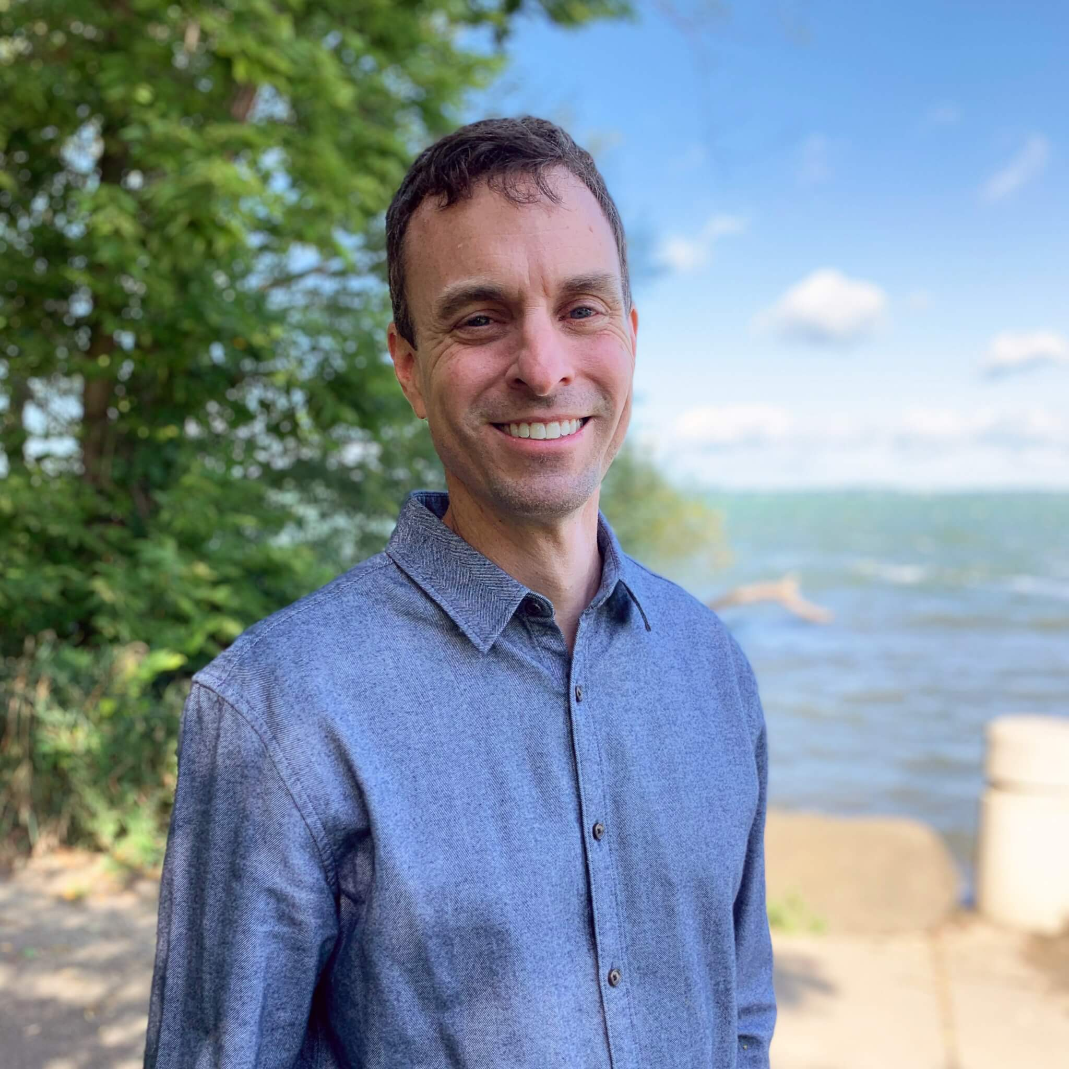
Paul Dearlove

Paul Dearlove joined Clean Lakes Alliance in 2014 and is the organization's Deputy Director and Chief Science Officer. His primary focus is on advancing community-based phosphorus-reduction actions around Greater Madison's chain of five lakes.
Paul also works to empower citizen participation by creating opportunities for people to become more informed and involved as donors, advocates, and volunteers. This includes overseeing the organization’s education and engagement programs, including Lake Forecast citizen monitoring, Volunteer Days, State of the Lakes reporting, Clean Lakes 101 Science Cafes, and immersion experiences like leadership training academies and youth camps.
He most recently served as the managing director of the Yahara CLEAN Compact, a 19-partner coalition that developed an updated roadmap for improving lake conditions called "Renew the Blue: A Community Guide for Cleaner Lakes & Beaches in the Yahara Watershed."
Prior to joining Clean Lakes Alliance, Paul spent 15 years as Lake Manager for the Lake Ripley Management District (Jefferson County, WI), which included directing the completion of a 13-year Priority Watershed Project through the Wisconsin Nonpoint Source Abatement Program. He also worked as a consultant preparing comprehensive lake and watershed management plans for Wisconsin lake districts and associations. Paul earned his M.S. in Water Resources Management from the University of Wisconsin-Madison’s Nelson Institute for Environmental Studies and has served on the boards of Wisconsin Lakes and the Friends of Lake Wingra. He currently serves on the board of the American Water Resources Association (Wisconsin chapter).

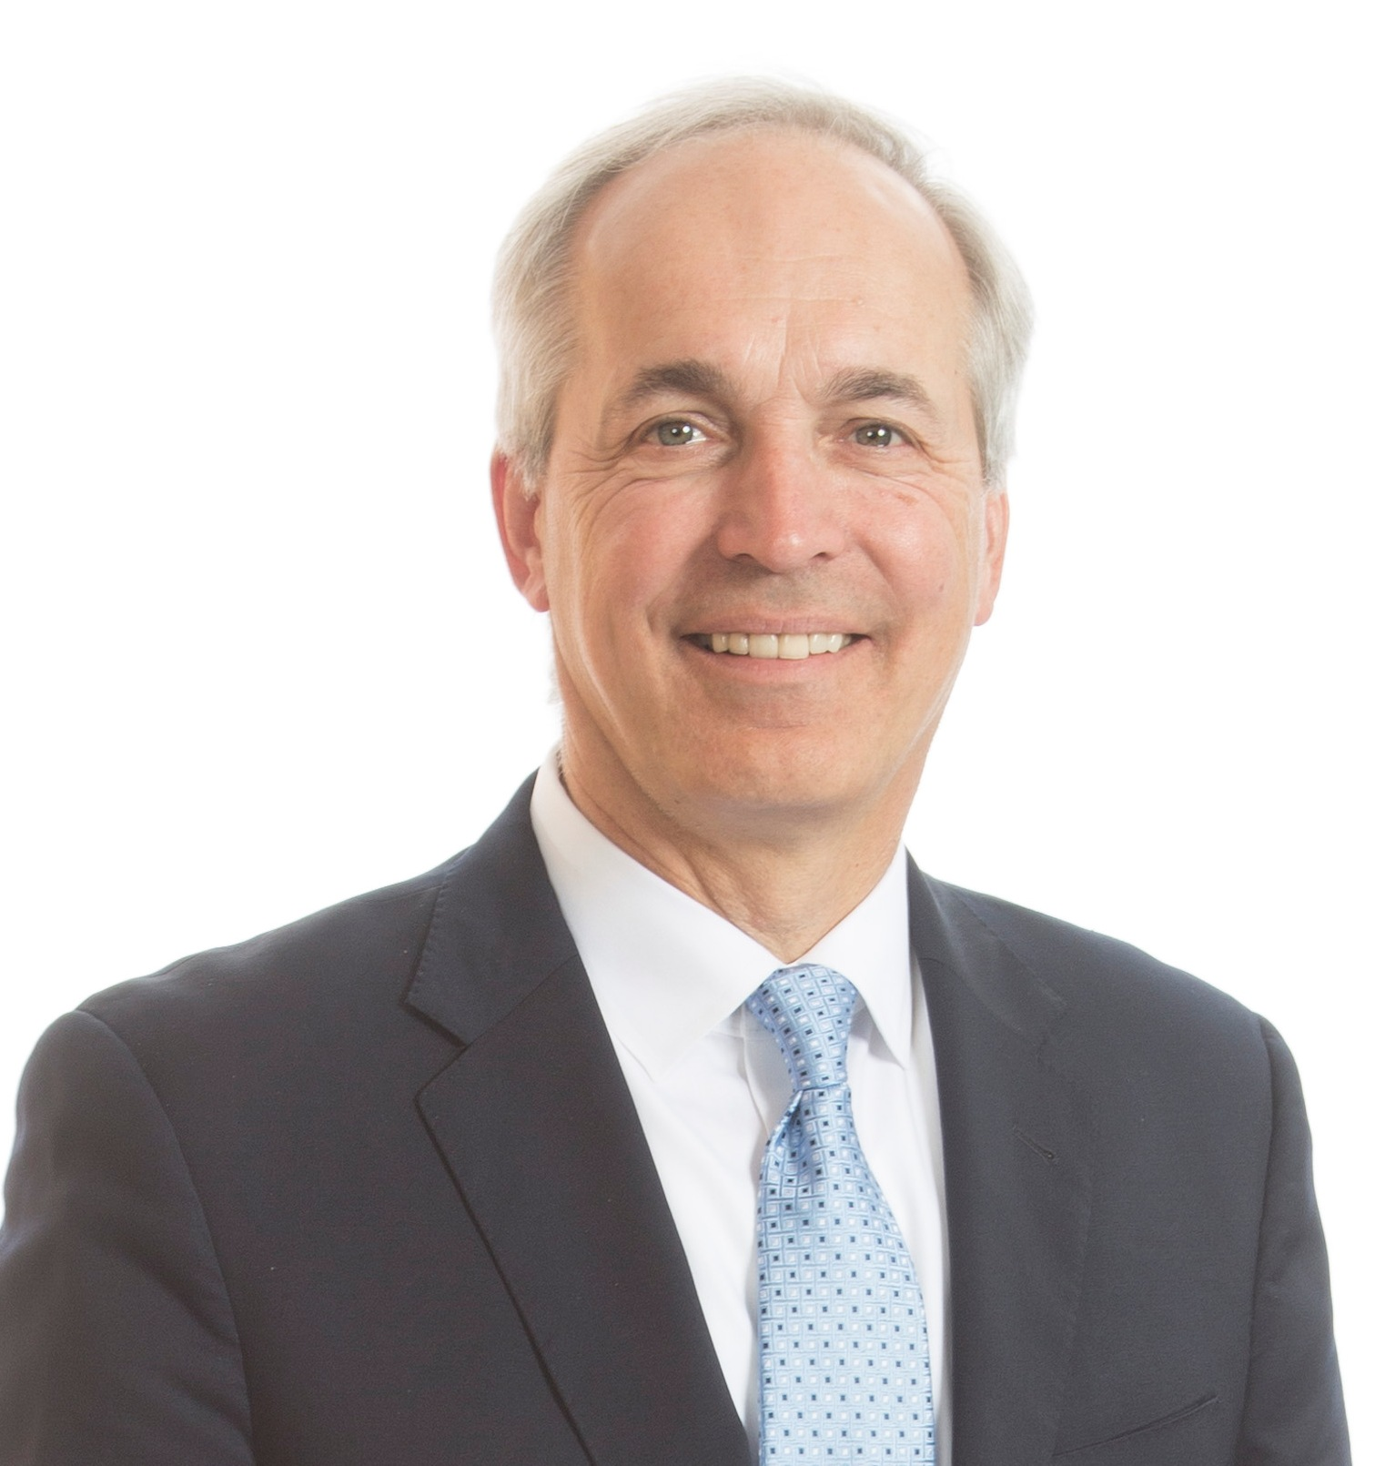

Matthew J. Frank, Esq.

Attorney Matt Frank’s practice focuses on environmental, natural resources, and renewable energy law. Matt provides experienced counsel to businesses, municipalities, utilities, and individuals in a wide range of environmental and energy matters, helping clients successfully navigate regulatory and legal challenges. Prior to private practice, Matt served in Wisconsin state government for 30 years, including a Secretary of the Wisconsin Department of Natural Resources (DNR) and as an Assistant Attorney General with the Wisconsin Department of Justice (DOJ).
During his tenure as DNR Secretary from 2007 through 2010, he oversaw the DNR’s regulatory and permitting programs, including air and water quality, waste and recycling, wetlands, groundwater, environmental clean-ups and brownfields restoration. Matt worked closely with businesses and communities on sustainability initiatives such as the Green Tier program and the Green Tier Legacy Communities Charter. He also worked on environmental and natural resource issues with officials in the Environmental Protection Agency, other federal agencies, and states across the country.
Matt's environmental achievements at the DNR include the start of full-scale clean-up of PCBs in the Fox River, passage of the Great Lakes Compact, initiatives to reduce mercury emissions from coal-fired power plants and reducing phosphorous in Wisconsin’s lakes and streams. He also instituted a partnership between the DNR and the University of Wisconsin to address climate change
Matt serves on the boards of three non-profits whose missions address land conservation and preservation, climate change, and clean water. He is a past Board Chair of the Clean Lakes Alliance in Madison, Wisconsin.

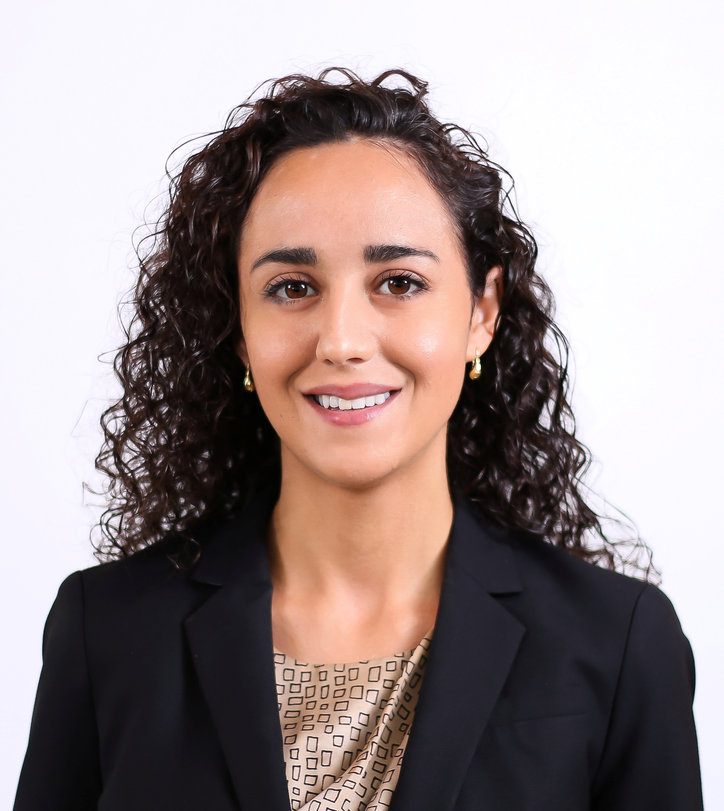
Maryam Ghayyad, Esq.

Attorney Maryam Ghayyad practices immigration and nationality law, including the full spectrum of family-based, employment-related, and individual immigration matters. She also represents clients in divorce and family law cases, including custody and placement of minor children, paternity, grandparents' rights, and post-judgment matters affecting families.
Maryam is fluent in both Spanish and English. She is a member of the American Immigration Lawyers Association (AILA), which allows her to remain current on frequent changes in immigration law. She has spoken to college and high school students on Deferred Action for Childhood Arrivals (DACA) in Madison and Janesville, Wisconsin. Maryam also volunteers as a bilingual attorney at the Family Law Assistance Clinic to help meet needs of unrepresented family law litigants.
In 2018, Maryam received an "Up and Coming Lawyer" award by the Wisconsin Law Journal for her work in the legal field, her contributions to the firm, and her community involvement. She became a shareholder with the firm in 2019.
Upon earning her law degree from the UW Law School in 2012, Maryam received the 2012 Bercovici Prize for Jurisprudence/Legal Philosophy for excellence in the study of jurisprudence and legal philosophy. She graduated summa cum laude from UW-Madison in 2005.

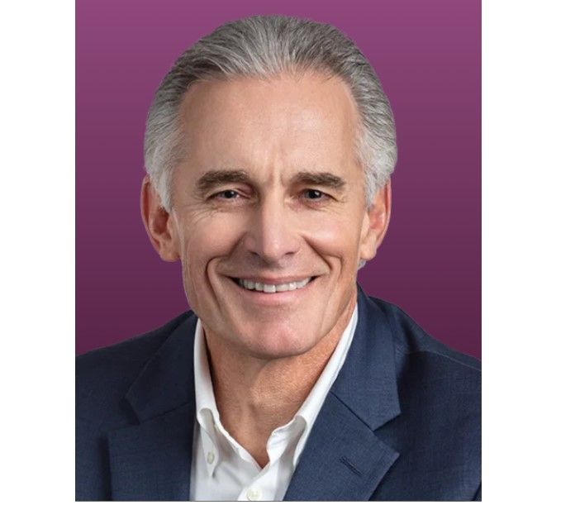

Tim Valentyn, Esq.

Tim Valentyn is a NFLPA certified Contract Advisor and has represented NFL football players and college and professional coaches for more than 30 years. He has a wealth of experience in all aspects of client representation having negotiated contracts for Wisconsin Football Coaches Paul Chryst and Jim Leonhard, long-time NBA head coach Stan Van Gundy, University of Wisconsin Basketball Coaches Bo Ryan and Greg Gard, among other notable players and coaches.

Along with client representation, Tim is a respected business leader in Madison, Wisconsin and was the President of Murphy Desmond S.C. for 15 years. He graduated from the University of Wisconsin – Eau Claire with a Bachelor of Science degree summa cum laude, is a member of UW-EC’s Athletic Hall of Fame and has been honored with the school’s Outstanding Alumnus Award. He earned his law degree from the University of Wisconsin, has been a guest lecturer at the UW Law School, and is a member of the State Bar of Wisconsin and the American Bar Association.

Time and his wife Nancy live in Verona Wisconsin and have two grown sons, Brett and Connor, both UW Law School graduates practicing in Madison and Chicago respectively.

Mark Maciolek, Esq.
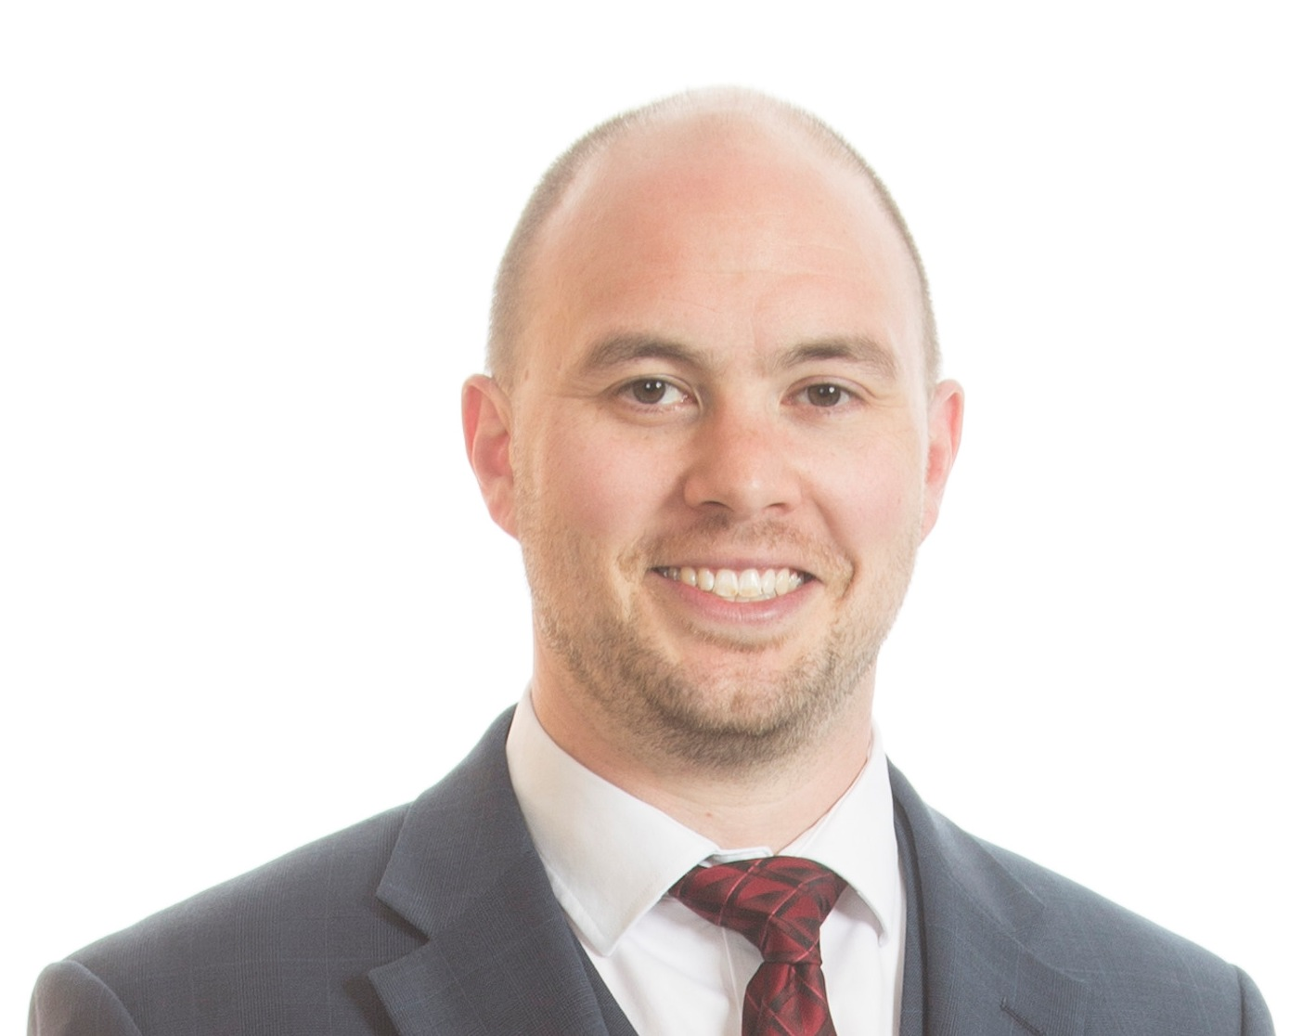

Attorney Mark Maciolek represents clients in criminal defense, bankruptcy, litigation, bankruptcy crimes, civil firearms rights and similar litigation matters in federal and state courts. Maciolek’s federal experience includes assisting clients charged with complex commercial crimes, federal conspiracy crimes, immigration crime, white collar crimes, federal firearms crimes, and many other areas. He handles state criminal matters and related areas, such as ordinance violations and juvenile defense. He also handles post-conviction proceedings, appeals, and habeas-corpus matters, especially in connection with the immigration practice group clients at the firm.
A shareholder at Murphy Desmond S.C., Maciolek is also a civil litigator with jury trial experience in state and federal courts. He practices in both trial courts and courts of appeals. His bankruptcy practice includes bankruptcy litigation.
Maciolek is bilingual and frequently assists Spanish-speaking clients. Prior to joining Murphy Desmond in 2013, Maciolek was a solo practitioner in Madison, Wisconsin. He is rated "Superb" on Avvo.com and was named a "Rising Star" in Criminal Defense Law by Wisconsin Super Lawyers.

James Tinjum, Ph.D.

Professor Tinjum is Associate Professor of Civil and Environmental Engineering & Director of the Geological Engineering Program at the University of Wisconsin–Madison.
His overall academic/consulting background and research/teaching/ outreach interests are inter-disciplinary, covering facets of geotechnical, geological, environmental, transportation, and sustainable energy engineering.
He conducts research in energy geotechnics (wind energy site civil, geotechnical, and structural design; evaluation of campus- and district-scale geothermal heating and cooling systems); the beneficial reuse of industrial byproducts (e.g., cement kiln dust, coal-combustion residuals, and lime for subgrade improvement and cementitious stabilization of pavement layers); life cycle environmental analysis of geo systems; remediation of contaminated sites; and heat transfer in porous media (soil and rock).
Professor Tinjum developed these interests as a consulting/industry engineer for 13 years at prominent engineer-procure-construct firms and a Fortune 50 company, and through discussions and interactions with practitioners participating in his nationally/internationally attended engineering short course programs.

POST COVID RETURN TO OFFICE PANELISTS
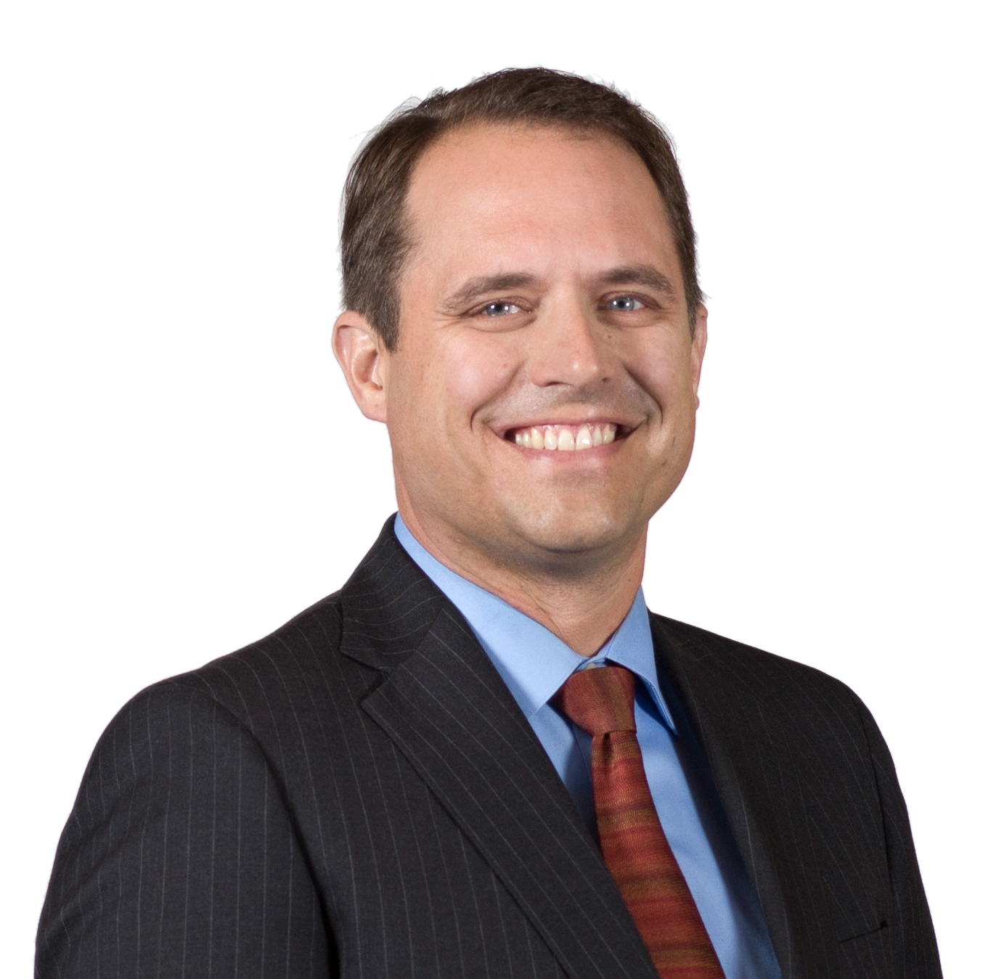

Matthew Fleming, Esq.

Attorney Matt Fleming is a shareholder at Murphy Desmond representing both public and private sector clients in municipal law and related areas including land use regulation, property tax assessment, eminent domain disputes, economic development, tax incremental financing, alcohol and other licensing and permitting issues, open meetings and public records law, ordinance drafting, real estate, special assessments and general litigation.
Matt is also an established presenter on municipal law issues. He has given Continuing Legal Education lectures on topics relating to local government law through Lorman, National Business Institute, and the State Bar of Wisconsin, including Open Meetings and Public Records Law, Building Code Enforcement, Land Use and Property Tax Assessment. He has been a frequent lecturer at the University of Wisconsin Law School on Local Government Administrative Practice between 2009 and 2019.
Matt was named "2023 Madison Lawyer of the Year-Municipal Law" and "2021 Madison Lawyer of the Year-Litigation-Land Use and Zoning" by Best Lawyers in America and is on Best Lawyers lists in three categories: Municipal Law, Litigation-Municipal Law, and Litigation-Land Use and Zoning. In 2015, Fleming was recognized by Martindale-Hubbell and lawyers.com with an AV (top) rating. He was also named a "Rising Star" by Wisconsin Super Lawyers earlier in his career.

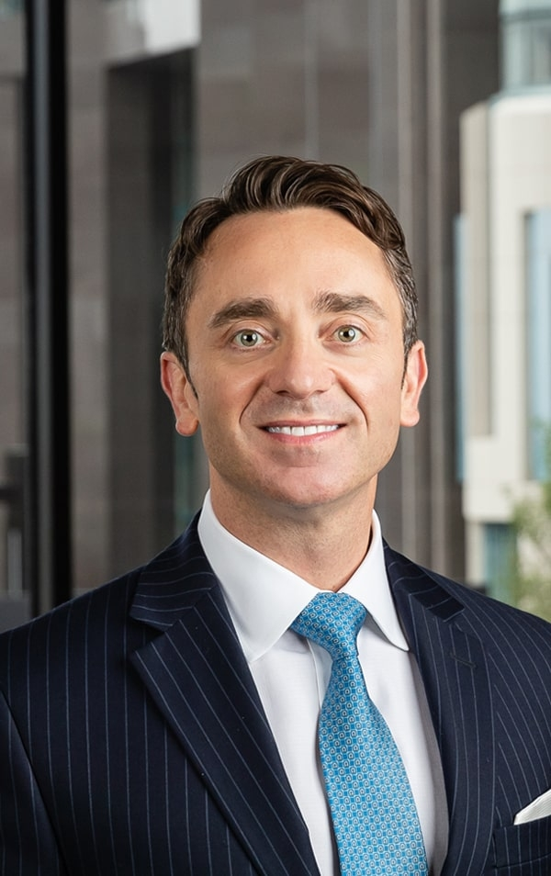
Anthony (Tony) J. Barbieri, Esq.

Tony Barbieri is a shareholder at Kessler Collins in Dallas, Texas. As president of Kessler Collins, Tony has garnered invaluable experience across industries, such as healthcare, biotech, manufacturing, hospitality and restaurants, and retail and service. His practice is largely centered around mergers and acquisitions, private equity and venture capital investments, debt and equity financing, and he has led the merger, acquisition and sale of many businesses in a variety of industries. In addition to mergers and acquisitions, Tony routinely handles private placements, private equity and venture capital investments, C-level employment agreements and employee equity plans, and general corporate counseling. His practice also involves advising clients regarding all of their business and legal needs, which includes complex real-estate transactions, employment matters, and intellectual-property rights. Tony also has a background in IT and Computer Science, which enables him to provide an unique perspective for clients related to matters that arise in the computer software and technology sphere. Tony also represents clients in state and federal courts across the country in various business disputes and other litigation matters.
Tony partners with his clients to provide more than legal counsel—he helps his clients identify and accomplish their ultimate business objectives by working collaboratively with them to craft efficient and effective strategies and solutions. Tony’s wealth of experience and strong relationship building skills have led to him filling the role of “outside general counsel” to a wide range of mid-market, high-performance companies across various industries.
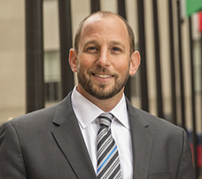

Neal Weinstein, Esq.

Attorney Neal Weinstein of Ingram Yuzek Gainen Carroll Bertolotti LLP in New York City handles complex commercial real estate transactions in New York and throughout the United States. Major components of his practice include the acquisition, disposition, and financing of multifamily and office buildings, shopping centers, and industrial projects. His practice also focuses on office, retail and restaurant leasing for both landlords and tenants.
He also advises leading entrepreneurs in various industries on business contracts, day-to-day operations, and handling (and avoiding) business disputes. Client industries include technology start-ups, investment funds, concierge services, hardware distributors, retailers, restaurants, designers, management and brokerage companies, contractors, and real estate companies. He has extensive experience in the resolution of real estate and commercial disputes including landlord/tenant proceedings in New York City.
Neal has been a presenter and panelist at industry conferences and events where he has spoken on topics including due diligence in real estate and corporate transactions, the pitfalls of subleasing, and the future of office spaces.
Prior to joining Ingram, Neal was a court agent at LeFrak. Neal frequently writes and lectures on hot topics facing the real estate industry.

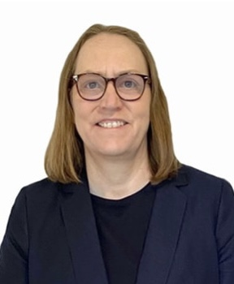
Jane F. (Ginger) Zimmerman , Esq.

As President of Murphy Desmond S.C., attorney Ginger Zimmerman is responsible for strategic planning, management, growth and development of the firm, in addition to representing her clients.
Ginger's legal practice combines her experience in business, real estate, bankruptcy, secured transactions, agricultural and commercial transactions, loan transactions, and litigation. She represents creditors, debtors, receivers and Trustees in bankruptcies, collections, foreclosures, reorganizations, liquidations, and Wisconsin Chapter 128 proceedings.
Ginger also represents purchasers, sellers, landlords and tenants of commercial and agricultural real estate. Her background in commercial and agricultural law is particularly helpful in structuring and negotiating financing for new businesses, refinancings, business acquisitions, expansions, reorganizations, and succession plans. Her practice includes representing borrowers, guarantors, and lenders in commercial and agricultural loan transactions.
In the area of business start-ups, Ginger assists entrepreneurs with entity formation, governance, contracts, real estate, and financing. Her experience in working with creditors and debtors in collections, bankruptcies and business reorganizations gives Ginger a unique perspective in helping owners avoid financial pitfalls of starting and operating a business.
Since joining the firm in 1992, Ginger has served in leadership roles including Chair of the firm's Board of Directors, Managing Shareholder, and Practice Group Leader (current Co-Leader) for the Creditors' Rights, Business Bankruptcy and Commercial Litigation Practice Group.
She currently serves on the board of the Bankruptcy, Insolvency & Creditors' Rights Section of the State Bar of Wisconsin.
Ginger was named "Madison Lawyer of the Year - Litigation-Bankruptcy" in 2021 by Best Lawyers and was named "Madison Lawyer of the Year - Bankruptcy and Creditor-Debtor Rights/Insolvency and Reorganization Law" in 2020, 2018 and 2016. She has been consistently included on lists for Best Lawyers (in three practice areas) and Wisconsin Super Lawyers, including "Top 25 Women" in Madison by Super Lawyers. In 2020, Ginger was included on the Lawdragon Inaugural "500 Leading U.S. Bankruptcy & Restructuring Lawyers" list, considered a pinnacle award. In addition, she was inducted into the Fellows of the American Bar Foundation, another exclusive honor. Ginger is rated AV (top rating) by Martindale-Hubbell and Lawyers.com, and 10.0 "Superb" on Avvo.com. Ginger was previously honored by the Wisconsin Law Journal as a "Women in the Law" for her work in the legal field and her support, mentoring, and encouragement of female attorneys in their careers.

LAW FIRM MARKETING 2.0 PANELISTS
Amy M. Gores

As the marketing director for Murphy Desmond, Amy Gores is responsible for the firm’s marketing processes that include advertising, public relations, website management (including SEO), social media, content marketing, online directories, and overall brand management. She directs and assists attorneys with individual marketing efforts and online reputation management and markets the firm and its numerous practice areas.
Amy also oversees the firm's sponsorships and charitable contributions programs. She sets and manages the marketing budget for all marketing programs and processes. Amy works closely with vendors, advertising reps, service providers, ad agencies, digital marketing companies, chambers of commerce, industry associations, and charitable organizations on behalf of the firm.
Prior to joining the firm, Amy managed branding functions, marketing, corporate communications, event/meeting planning, and incentive program processes for a large insurance company. Early in her career, she handled public relations for a non-profit organization. Amy is a member of the American Marketing Association (AMA), the Legal Marketing Association (LMA), and Public Relations Society of America (PRSA). She is currently earning her Accreditation in Public Relations (APR) through PRSA and enjoys freelance writing in her spare time.

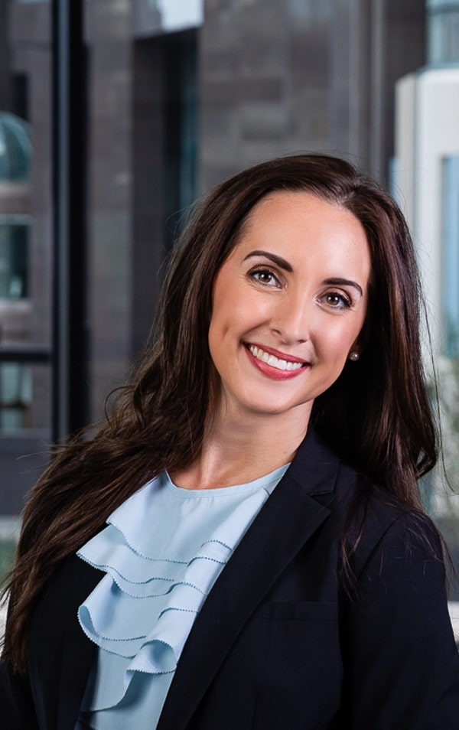
Chandler Saul, Esq.

Prior to law school, Chandler Saul worked in the deregulated energy market as a commercial energy broker and negotiated energy contracts and power purchases for commercial energy users across deregulated markets in North America. Through this experience, she developed strong negotiation skills and the ability to strategically advance her client’s short-term and long-term objectives and priorities. These are skill sets she utilizes daily in her legal practice.
Chandler represents clients in a variety of corporate and transactional matters, including mergers and acquisitions, corporate restructures, private equity, and venture capital investments and strategically evaluating how to protect client’s intellectual property. She also particularly enjoys partnering with entrepreneurs to develop and launch new business ventures. Chandler takes a holistic approach to providing sound advice to her clients by strategically evaluating the unique mix of dynamics at play in each circumstance and crafting innovative and dynamic solutions and approaches to benefit and advance her clients’ goals and objectives.
She believes a key to successfully representing her clients is truly understanding their businesses so she can best personalize her representation to their unique business models and dynamics. This allowed her to gain a depth of knowledge and experience in a variety of industries, such as healthcare, finance, technology and web development, food and beverage industry, cyber security, the oil and gas and alternative energy sector, commercial leasing, and land use and development to name a few.
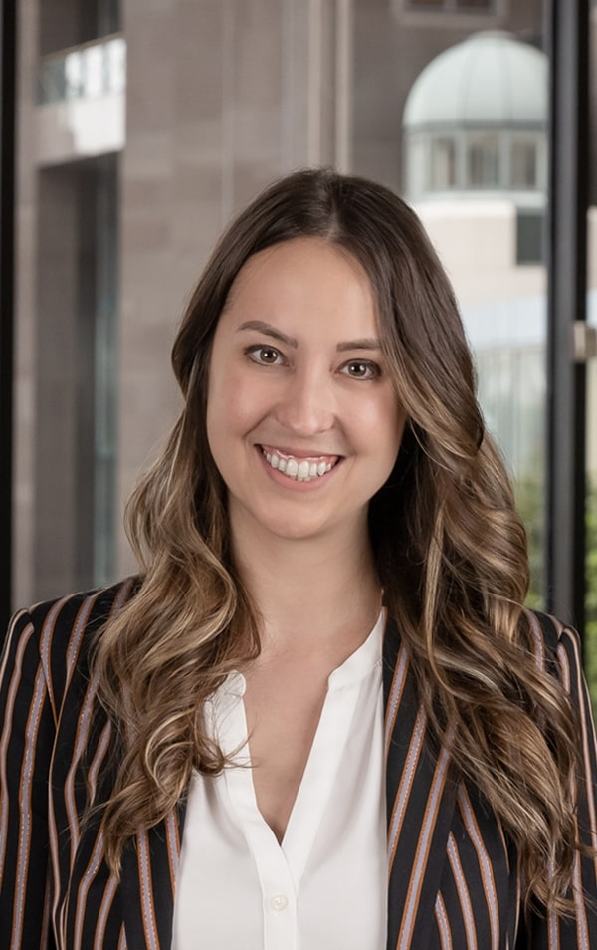
Anne-Alise (Ali) Hinckley, Esq.

Ali Hinckley is a member of the firm’s litigation group who represents clients in a variety of sophisticated commercial, business, securities, consumer, labor and employment, real estate, oil and gas, construction, and insurance disputes.
She has experience in all aspects of civil litigation, including depositions, complex discovery, mediations, trials, and arbitrations. Ali takes pride in her efficient, no-nonsense approach to her practice. She is a seasoned trial attorney and has successfully represented her clients in state court, federal court, and federal administrative proceedings.

